Big Red Recruitment

**Test Plan**

*Purpose: [Insert description of doc here]*

**Team members: Alexander Mckie**

**Date/Version: 25/5/23 version 1**

# Overview

## Purpose

The Purpose of this Document is defining the context of the testing going to be done to ensure our program works correctly. We will out line the methodology, test environments and types of tests going to be performed. The standards will be outlined, and the outcomes of the test will be as well. The scope will be outlined with the functional and non functional test.

## Context

The application lets the user compare 2 separate list of objects Contractors and Jobs and make changes to the objects as task are completed and new task arise. The benefit of testing the program is that we can be certain it will work as described to the client.

The stakeholders are the client and developer the client’s role in the testing is to describe what the want from the application clearly and revaluate the program to ensure it doing what they want. The developer’s role in testing is to run test on the program to test its capabilities to ensure it doing what it supposed to be. The developer will run test to see if a user tries entering wrong data fields, they will be redirected to use the correct data fields.

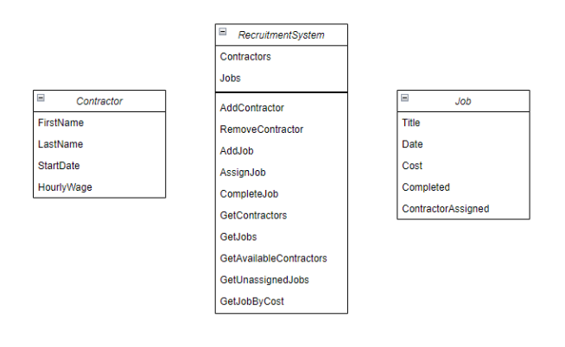

## Methodology

We are using Unit Testing and Functional testing in the program.

Functional testing outlines what the program is to do broken down into what a user is going to do with that program. You write up a Test for each action you anticipate a user do and what the desired outcome should be. You then manually run the test on the program and confirm the results in a table. This is not an automated test. We run this type of testing to test the functionality of the program by doing task as the user is going to do them step by step and make changes that are in relation to user interface that wouldn’t be picked up by an automated test. The benefits of doing this is that you can see first-hand how the program is going to run from a user’s point of view.

Unit Testing is where you create a separate program in your program that contains a set of functions that will test the functions you have created in the main program. We do this to test that our program is going to work by giving each function a test scenario where its runs through a set of statements and the result is matched to a desired result. This is an automated test which is run in the program the befit of this is that if a bug appears if you change another part of the program it will show up in the unit test. Another benefit is that you can create the unit test first and build your program to ensure its going to work to the unit test.

## Test environment

The Unit Test environment is a Unit Test project (.NET Framework) program within our visual studio solution.

# Testing Plan

## Scope of Testing

### Functional tests

## Debugging Screenshot

